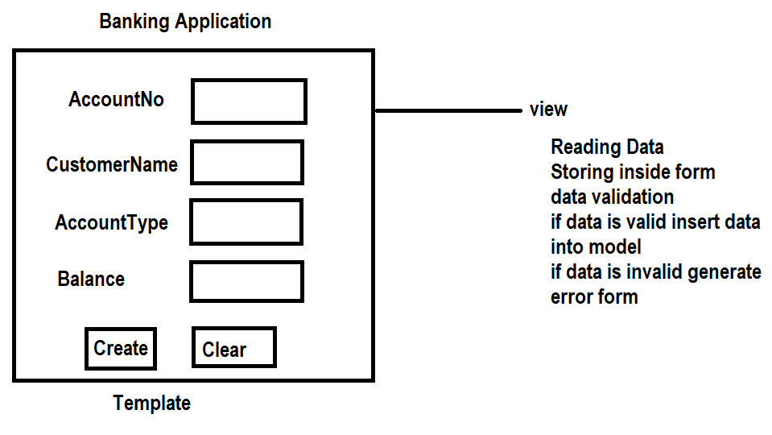

Views.py
from django.shortcuts import render
from app.forms import AccountForm
from app.models import Account
from django.http import HttpResponse
# Create your views here.

def accview(request):
if request.method=="GET":
accform=AccountForm()
response=render(request,"acctemp.html",context={'accform':accform})
return response
else:
accform=AccountForm(request.POST)
if accform.is_valid():
accform.save()
accform=AccountForm()
response=render(request,"acctemp.html",context={'accform':accform,'msg':'Account Created'})
return response

response=render(request,"acctemp.html",context={'accform':accform})
return response

def accupdate_view(request,accno):
if request.method=="GET":
try:
acc=Account.objects.get(accno=accno)
account={'accno':acc.accno,
'cname':acc.cname,
'acctype':acc.acctype,
'balance':acc.balance}
accform=AccountForm(account)
response=render(request,"acctemp.html",context={'accform':accform})
return response
except:
response=HttpResponse("Invalid Accno")
return response
else:
acc=Account.objects.get(accno=accno)
accform=AccountForm(request.POST,instance=acc)
if accform.is_valid():
accform.save()
response=render(request,"acctemp.html",context={'accform':accform,'msg':'Account Updated'})
return response
response=render(request,"acctemp.html",context={'accform':accform})
return response

forms.py
from django import forms
from app.models import Account

class AccountForm(forms.ModelForm):
class Meta:
model=Account
fields="__all__"
exclude=['accno']

def clean_acctype(self):
data=self.cleaned_data
if data['acctype'] not in ["saving","current"]:
raise forms.ValidationError("Acctype must be saving or current")
return data['acctype']
def clean_balance(self):
data=self.cleaned_data
if data['balance']>=5000:
return data['balance']
raise forms.ValidationError("balance must be >=5000")
def clean_cname(self):
data=self.cleaned_data
if data['cname'].isalpha():
return data['cname']
raise forms.ValidationError("name should contain only alphabets ")

models.py
from django.db import models

# Create your models here.
class Account(models.Model):
accno=models.AutoField(primary_key=True)
cname=models.CharField(max_length=20)
acctype=models.CharField(max_length=20)
balance=models.FloatField()

acctemp.html
<!DOCTYPE html>
<html lang="en">
<head>
<meta charset="UTF-8">
<meta name="viewport" content="width=device-width, initial-scale=1.0">
<title>Document</title>
</head>
<body>
<form method="post">
{%csrf_token%}
<table border="2" width="100%">
{{accform.as_table}}
<tr>
<td><input type="submit" value="submit"></td>
<td><input type="reset" value="clear"></td>
</tr>
</table>
</form>
{{msg}}
</body>
</html>

Urls.py
from django.contrib import admin
from django.urls import path
from app.views import accview,accupdate_view
urlpatterns = [
path('admin/', admin.site.urls),
path('accview/',accview),
path('accupdateview/<int:accno>/',accupdate_view)
]

Settings.py
DATABASES = {
'default': {
'ENGINE': 'django.db.backends.mysql',
'NAME': 'db11',
'USER':'root',
'PASSWORD':'root',
'HOST':'localhost',
'PORT':'3306',

}
}

TEMPLATES = [
{
'BACKEND': 'django.template.backends.django.DjangoTemplates',
'DIRS': [BASE_DIR/"templates"],

INSTALLED_APPS = [
'django.contrib.admin',
'django.contrib.auth',
'django.contrib.contenttypes',
'django.contrib.sessions',
'django.contrib.messages',
'django.contrib.staticfiles',
'app',
]

